8 Key Benefits of Virtual Teams for Your Company!

Editorial Team

BIT.AI blog

https://blog.bit.ai/benefits-of-virtual-teams/

n.d.

“One day, offices will be a thing of the past”- Richard Branson
These words were said by Richard Branson in 2013, and who thought they would make more sense in 2020!
In this constantly moving world- literally and technologically, the concept of “in-office” seems to be best left behind in the 20th century. Especially, with the increased need for people to work from home due to the COVID-19 pandemic, organizations around the globe have been thrust into working remotely.
A survey by Gartner revealed that around 50% of companies currently have 81% or more of their employees working remotely during this COVID-19 pandemic. Another 15% of companies said 61-80% of their employees were already virtual.

This is why it’s no secret that the concept of having virtual teams in an organization is quickly becoming the new norm.

What are Virtual Teams, you ask?
A virtual team is a group of employees working remotely for a company. These employees are spread across multiple locations around the world, sometimes distributed across different time zones but unified by the same goals! Virtual teams are brought together by technologies that run on the cloud and help them collaborate while working remotely.

No matter if you are running a small start-up or a long-term profitable business, having a virtual team is always an advantage for the company as well as the workforce! How?
Well to answer that, we have listed down 8 major benefits of having a virtual team for your company!

Virtual Teams – Adapting to a New Way of Working
With the pandemic and slowing down of businesses across the globe, many teams have been forced to go remote. These teams are revamping their work cultures to adapt virtual employees with different levels of “remoteness” by introducing a virtual team structure!

According to a survey by Buffer, 31% of companies chose to have their teams completely virtual! These companies also made it possible to make this a sustainable phenomenon by taking advantage of the available technology that would not only increase their adaptability to changing 21st-century conditions but help them stay ahead of the competition in a globalized market.

However, managing a global virtual team actually comes with many more benefits! Let’s check them out!

Benefits of Virtual Teams!
Creating a virtual team poses many benefits that can help your business reach new heights of success with increased productivity in the world of remote working. Here are 8 major benefits of virtual teams that will motivate you to engage more virtual employees for your company :

1. Higher loyalty rates are found in virtual teams
Even though employees are working remotely at their home or a preferred location, being part of a virtual team makes them feel important and that their opinion matters. Also, as managers giving your team some flexibility is a great way to help them provide genuine feedback and, skyrocket the retention rate.
In fact, a survey shows that around 79% of employees said they would be more loyal to a company that provides flexibility. Whereas, 32% said that they have left a job because of the lack of flexibility.

2. Your business can be operational 24/7.
Imagine having business processing 24 hours a day, 7 days a week! In earlier days, people worked overnight to complete their office shifts, but today, they can take advantage of the global nature of virtual collaboration, data sharing, and working in different time zones.

That means your virtual team’s collaborative efforts never need to stop, keeping them ahead of the schedule!

3. The presence of a virtual team creates a happier employee
Employees who are able to telecommute are generally happier and healthier as they have more control over their employment conditions. There is more flexibility offered with a virtual workplace to balance hobbies than there is with a traditional one. This is why 83%of the businesses have started a flexible work policy in their workplaces.

Being part of a virtual team is a powerful motivator, 1 in 3 employees would choose to work remotely rather than get a pay rise.

4. Workers on a virtual team take fewer days off
Telecommuting (that is, work from home or remote working) as a virtual employee decreases the use of sick days by 6% per year. Many workers on virtual teams find themselves working for longer hours and more days. They are more likely to work in excess of 40 hours a week and if they’re working from home they end up taking fewer sick days. In return, they get an opportunity to work in a way that is beneficial to them for a balanced life.

5. A dramatic rise in productivity
Some worker’s involvement in a virtual team is strengthened such that their productivity increases by more than 40%. An effective virtual team sees productivity rise at least 10% even in the worst-case scenario!

Also, by executing the concept of virtual teams, you deduct around 30-40 minutes of travel time for these workers, giving them 1 hour free that can be used to do some extra work and be more productive. Hence, most employees complete more work when they aren’t required to physically report at the office.

6. Virtual teams are monetarily beneficial
Did you know that Cisco saves over $277 million per year by using virtual teams and remote working? Companies that do not have to pay for office space and supplies can save quite a bit in a year. Another study shows that if a company let an employee work from home just for the half time, it would save an average of $2,000 to $7,000 per employee.

7. Companies have access to a larger pool of talent
When a company builds virtual teams, they are no longer bound to the skills and talents available within the internal workforce and their local community. Thanks to the web, an entire pool of talented people are a few clicks away.

CEO of Upwork, Stephane Kasriel, once said:
“Companies that refuse to support a remote workforce risk losing their best people and turning away tomorrow’s top talent.”

8. Virtual teams reduce the environmental impact of your business
When employees are working at home virtually, instead of commuting to the office daily, there are fewer carbon gas emissions being released into the environment.

This results in reduced greenhouse gas emissions by 54 million tons every year. Also, working in a virtual team, in turn, reduces the resources needed within the office, which means less paper, heating, electricity, and a reduction in gas consumption by more than $20 million.

The Bottom Line
Managing a virtual team can be worthwhile for your company, as it gives you the ability to access a larger pool of talent, control costs, enhance productivity and so much more.

Also, there are tools that can make these virtual workplaces more creative and change the way businesses communicate in the document form- one such tool is Bit.ai. It is the most advanced end-to-end document solution for virtual teams to communicate externally and internally. It allows you to create, manage, and track all of your team’s documents in one place.

Thus, it’s time for you to set up a highly driven virtual team of your own that is ready to take your business above and beyond expectations. Using the right tool like Bit to manage your virtual team in the current scenario, success isn’t far away!

10 Ways to Successfully Manage Virtual Teams
By Rocco Baldassarre
ENTREPRENEUR LEADERSHIP NETWORK WRITER
Founder & CEO of Zebra Advertisement & 1DollarAd.com
March 24, 2015 4 min read
Entrepreneur
https://www.entrepreneur.com/article/244197

If you are managing one or more virtual teams, you are not alone. The Workforce 2020 survey claimed that 83 percent of executives plan to increase use of consultants or intermittent employees over the next three years.

Virtual teams can be a challenge to manage because one needs to create a corporate culture remotely. Here are 10 strategies to successfully build a virtual team that can be implemented instantly.

1. Define work systems.
Different people have different ways of going about tasks. Setting standards can shorten the time needed to achieve the desired result. By setting standards and defining repeatable work systems, the team has generally less questions and gets a feeling for how long certain tasks should take. These work systems need to be both standardized to allow for maximum effectiveness and tailored to allow the necessary freedom to complete the task at the best of one’s ability.

2. Establish multiple communication tools.
The benefits of establishing multiple communication tools is two-fold. First of all, your team has a way to communicate something that is urgent to the right person immediately. Secondly, it unifies processes such as what to use for conference calls, screen recordings, and so on. It is clear what tool is used for what, which contributes to creating that internal feeling of togetherness.

3. Schedule regular meetings.
Scheduling briefings at the same time on the same weekday contributes to creating a routine. Routines provide the team with something they are used to and familiar with. That in return puts the team at ease and reduces stress. Video calls are one of the best ways to maximize efficiency because they recreate the routine office feeling remote teams are missing out on.

4. Have clear and detailed deliverables.
Simply telling somebody to do something is usually not the popular way to go about managing teams. Micro-managing isn’t either which is why some managers avoid giving instructions with too many details.
Based on my experience, it is better to provide more detailed descriptions of the tasks with examples of what the final result should look like. Give the team the freedom to execute it than less instructions and having to deal with potential misunderstandings.

5. Make sure work hours overlap.
Regardless of what time zones your team members are in, it is recommendable to have at least three to four hours a day where most of the team is online at the same time. Even if some of the team members are unlikely to need each other to complete their tasks, being online at the same time brings the team closer together and is the quickest problem solving solution there is.

6. Create a professional work environment.
Professional attire and a distraction-free work environment are part of any corporate culture. Additionally, setting professional standards contributes to being efficient and puts people in the right mindset.

7. Choose (video) calls over chatting and emails.
With Skype and email being available at everyone’s fingertips, it is tempting to chat and send a quick email whenever there is something to discuss. This can easily lead to misunderstandings. With virtual teams, video calls or at least regular calls are more than a way to avoid misunderstandings. They connect the team members on a more personal level.

8. Find the right people to work with.
Not everyone is cut out for remote work and not everyone fits the team personality-wise. There are quite a few professional personality tests out there, and they can be a great way to determine whether someone is the right fit is still to ask yourself whether you are sure about that person or not. If you are not, it is usually best to move on to the next candidate. Additionally, double checking all references is a must to make sure you know as much as possible what you are getting yourself into.

9. Establish a meritocratic system.
Meritocracy -- or the process of rewarding and recognizing people based on their skills -- stimulates people to work harder and better. Make sure to set up reward systems to keep your team motivated and to better pinpoint the team members that can take on more responsibility.

10. Use project management tools.
Project management tools can be ideal to keep track of deadlines. They also send alerts and reminders for deadlines and give you a quick daily, weekly or monthly overview of what needs to be done, by who, and when. Things like Google Docs can still be a great addition and the same is valid for time tracking applications.

5 Best Ways To Build A High-Level Virtual Team
Last Updated on 21 March, 2021

Barasha Medhi

Vantage Circle

https://blog.vantagecircle.com/virtual-teams/

If the current pandemic we are facing has taught us anything, it’s that people can work together just as well from the safety of their homes. Cue: virtual teams.

Virtual teams, popularly referred to as distributed teams or remote teams are groups of individuals who collaborate together from different locations and time zones by relying on virtual communication tools.
Virtual teams have become a necessity for businesses now. What are your options to make it run effectively as ever? Here are a few of our favorites:

1. Set up an effective communication strategy
It is rightly said that:
Communication is "the oxygen of a distributed company."

A good communication strategy will be as fundamental as keeping your stakeholders on board. Without such plans in place, there will be a complete lack of coordination and transparency among the dispersed team members. Even if you create virtual breakout rooms, make sure you do it right.
After that, it is only a matter of time before your virtual team is treading the deep waters of not getting successful outcomes.

A good communication strategy should mainly focus on four major points:
- Make sure to share information that is factually correct or relevant.
- The projected information gets delivered to everyone intended.
- The data is easily understandable by the recipients.
- The recipients or the team should be encouraged to display/practice a certain level of communication skills.

2. Invest in the right communication technology
Unless you are part of a virtual team, it is easy to underestimate the importance of communication for team building and engagement. When you can’t any longer pop into each other’s cubicles to discuss the smallest things, you learn to appreciate how good communication keeps a team functioning smoothly.
Without their usual face to face interactions, the overall team performance will most likely take a significant hit.

That is why having a functioning communication toolbox is perhaps one of the essential requirements of a dispersed team. A well-planned communication toolbox should at least have these basics:
- An excellent video conference tool is a must for conducting virtual meetings among remote workers. Some of the great tools for virtual teams to connect over is Zoom, Google Meet, or Google Hangouts.
- A chat tool for a virtual team to help continue their relationship building. Slack and Skype are extremely helpful for virtual knowledge sharing.
- A virtual meeting scheduling app (such as Google Calendar) for remote team members to stay updated on each other’s schedules.
- Document/Resources accessibility is a massive part of making remote work feasible and to share information. Services to share documents are provided by many, but the more popular ones seem to be Google Drive and Dropbox.
- An agile project management tool is the best thing that you can invest in right now. Not only will it help your team keep track of the upcoming projects, but it will also hold everyone accountable for their goals and tasks.

3. Track goals and commitments
In a study of 70 virtual teams, almost 82% fell short of their goals, and 33% rated themselves as mostly unsuccessful.

A considerable part of this is because of the lack of the right productivity measures. Having a virtual team doesn’t throw accountability out of the window. Now it’s even more relevant to business success.
Thus, managers should set clear employee goals and commitments to achieve for remote workers. It is important to set SMART Goals and make sure that employees are aware of the expectations. It can also get facilitated by holding regular “status virtual meetings.”

Simultaneously, it is also equally necessary to have a precise system to assess the employees’ performance.

Tracking performance will allow you to hold an employee accountable to his remote work and help you gather data about which tactics helped to maximize productivity. However, managers should never indulge in micro-managing.

Try to encourage the dispersed team to stay true to their commitments. Not only will it help to build trust, but it also will help in relationship building.

4. Appreciation matters!
Remote team members require as much as, if not more, recognition. While remote workers have a better work-life balance, they still need connection and appreciation from the rest of the team.
A regular 9-5 employee is “in the moment” while working and is well aware of his significance to the team’s success.

Now that we are collectively going through a pandemic, it’s necessary to acknowledge the positives more than ever. Any employee working through such times and managing to deliver excellent results should be appreciated timely and frequently. Even a few words of appreciation can turn the day around for most of the remote workers.

Not only will appreciating your remote workers make their day a little easier, but it will also help you to establish that you care from them.

5. The right leader
A recent study pointed out that managers with previous experience of leading a virtual team will show better success when doing it again.

Even though if you are a novice to managing virtual teams, having the right leadership qualities will help you gain some traction over it:

Build Trust
It might be frustrating to know that you can’t control the team or circumstances but always be respectful towards the virtual team members. Also, don’t leave empathy far behind.

Encourage open communication practices
Once you’ve established and built trust among your dispersed team, it’s essential to encourage open dialogues. A good practice is to ask before any virtual meeting an open icebreaker question about their day so far.

Be There
It is perhaps the more important of them all. Be there to guide the remote team members through any difficulties. You might be doing remote work, but it’s your job to be present.

Conclusion: Virtual Teams Are Crucial To The “New Normal”

The seven secrets of successful virtual meetings
CONFERENCE PAPER Innovation, Teams 10 May 2011
Pullan, Penny

How to cite this article:
Pullan, P. (2011). The seven secrets of successful virtual meetings. Paper presented at PMI® Global Congress 2011—EMEA, Dublin, Leinster, Ireland. Newtown Square, PA: Project Management Institute.

Abstract
Virtual meetings are a key part of the lives of today's project managers. The trouble is that they are often difficult to handle and most conference calls, audio conferences, and online meetings are frustrating timewasters. This paper outlines the seven secrets that project managers need to know to have successful virtual meetings, based on the author's work with hundreds of project managers worldwide in multinational organizations from pharmaceutical and IT companies to banks and government agencies.

This paper will help the reader to:
- Understand what goes wrong with virtual meetings and be able to diagnose how virtual meetings can improve;
- Prepare for and structure the next virtual meeting in a way that makes it more likely to succeed; and
- Think through all the aspects of virtual meetings beforehand to check that the virtual meeting will be as productive as possible.

This paper explores the vital area of how to run effective project meetings when you cannot be face-to-face with your team and stakeholders. Issues covered include building trust remotely and being aware of cross-cultural issues. We will touch on the tools used (but not go into detail on specific tools by vendor), look at communication on global projects, how social media can help, and how to prepare for and structure effective online meetings.

Why Are Virtual Meetings So Important for Today's Project Manager?

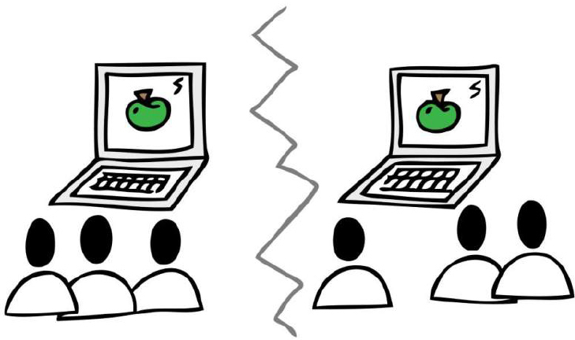

Exhibit 1: Cartoon showing two working groups in a virtual meeting with a common, shared screen.

Over the last decade, the number of virtual meeting has increased dramatically, from the occasional conference call to a situation where many project managers spend a large proportion of their time on conference calls and other virtual meetings. This increase has been driven by several global trends:
- The development of new technologies such as VOIP telephony (voice over internet protocol, an example of which is Skype) and shared computer screens;
- Project managers often being located away from many of their project team members and stakeholders, with many more regional and global projects, especially since the surge in outsourcing and off-shoring; and
- Telecommuting.

In the past year, the trend has been exacerbated due to these reasons:
- Volcanic ash clouds over Europe in Spring 2010;
- The fear of epidemics, such as swine flu; and
- The need to cut travel to reduce costs in an uncertain economic climate, with ever-higher petrol prices.

At the same time, climate change is an issue. Around 8 percent of the world's carbon emissions come from business travel, and perhaps a third of this could be replaced immediately with virtual meetings, if people knew how to use them effectively (Kane, 2010, p. 70; The Climate Change Group, 2008).
My story demonstrates how quickly a project manager may need to switch to virtual working due to the environmental pressures. In 2001, I was running a global project in a multinational company, improving processes in preparation for the implementation of SAP. My project team was dispersed all over the world, so I spent a lot of time travelling to meet people and run workshops.

Then something happened which changed everything. I was getting ready to run a workshop in the United States. I was planned to fly out on 13 September 2001. Unfortunately, two days before, 9/11 terrorist attacks happened. Air travel just stopped. For several months, none of us were allowed to fly anywhere. I had to work virtually. We had an early form of instant messenger. We had some primitive screen sharing applications. We had audio conferencing. We even had video conferencing. On top of this technology, I had the advantage of having been trained as a facilitator. So, as one does, we made do. We found people to advise us and got on with doing the project as best we could, learning all the time. I’m still learning nearly a decade later as I work with people in multinational companies who are struggling to be effective when they can’t meet face-to-face.

What Goes Wrong With Virtual Meetings Today?
Unfortunately, working virtually has not lived up to all the expectations. When I speak to project managers at professional associations and on client sites, I ask them how many hours per week they spend on conference calls. To date, I have always found several project managers who spend more than 20 hours per week on these calls, most often from the pharmaceutical or telecoms industries. When I ask groups if they feel that their conference calls are the best use of their valuable time, only one person has ever agreed. Hundreds have disagreed.

This seems to fit what others find. One survey showed that only 23% of managers gave their full attention during conference calls, while 25% dealt with their e-mail, and 27% did other work. This level of distraction is much higher than in face-to-face meetings (Hall, 2007, p. 53).

To find out more, I conducted a survey of project managers in 2008 (Pullan, 2008) and found out what they were frustrated about with their virtual meetings. Here are some of the points that came up, in no particular order:
- People are easily distracted by other things such as work, e-mail, instant messenger, Facebook and more.
- Sometimes you can’t hear clearly because of background noise. This can be due to people using speaker phones.
- Actions are far less likely to be done after virtual meetings compared to face-to-face meetings.
- The start of the meeting is often delayed, especially if you have complex technology to set up and people who are new to it.
- Often there is no level playing field; people are expected to dial in to a face-to-face meeting and sit listening all day, possibly in a different time zone.
- Not knowing who else is in the meeting let alone who is speaking at any particular time.
- Lack of preparation.
- Not being able to get a word in.
- When you ask a question, nobody answers. When you ask for volunteers or you want someone to take an action, there can be absolute silence.
- Conference calls and virtual meetings can last far too long and people's concentration levels tend to drop.

How Can We Improve This Situation?
When working with virtual meetings, many different variables come into play that the project manager must be aware of, including: the levels of trust in the team; the urgency of the work; the potential for conflict; the need for in-depth conversations; the mixture of cultures; the need for engagement and enthusiasm; the variety of time zones; and the need for creativity and innovation in the team, as well as both access to and familiarity with the technology involved among team members (Pullan & Settle Murphy, 2005). Sometimes, especially at the start of a project, given the mix of these variables, it would be a good idea to bring everyone together before working virtually later on.

Once the project manager has decided that virtual working is appropriate, there are seven secrets which, when applied, will make their virtual meetings much more effective.

Secret #1: Technology Is Not the Silver Bullet
The range of technology available for virtual working is growing all the time. Compared to when I started out in 2001, tools are very sophisticated with much more life-like “tele-presence” video conferencing on the market nowadays.

I have learned from my clients that people often think that technology will solve all the issues of virtual working. Examples range from the CIO of a multinational spending six figures on tele-presence to the charity buying new laptops with webcams for every employee. In both cases, they thought they were doing the right things for their people. Although the tele-presence video suite is much closer to real life, to use it means travelling to the video suite. Will everyone be able to do this for each virtual meeting? No! Virtual meetings across time zones often involve participants joining outside working hours. Would you rather dial into a conference call at 3 a.m. or get dressed, drive into the office, go to the video suite, have your meeting, go home and go back to bed? I know which one I would prefer to do!

I once worked on a project with governments in West Africa, with the United Nations, and with representatives from international chocolate companies. We had to have all our remote meetings by conference call because telephones were the most reliable technology. If you are working across companies, the likelihood is that you will need to have a backup plan in place, because technology does not always work seamlessly due to company firewalls and other security. I advise clients to have a conference bridge line that you can call as a fall back. Share the presentations beforehand. Practice the technology. Then your meeting technology should support you, but there is much more to effective virtual meetings than that.

Secret #2 Make the Most of Different Time, Different Place
It is natural for a project manager to replace a face-to-face meeting with a conference call, video conference, or online meeting. All three of these happen synchronously, the same as a face-to-face meeting.

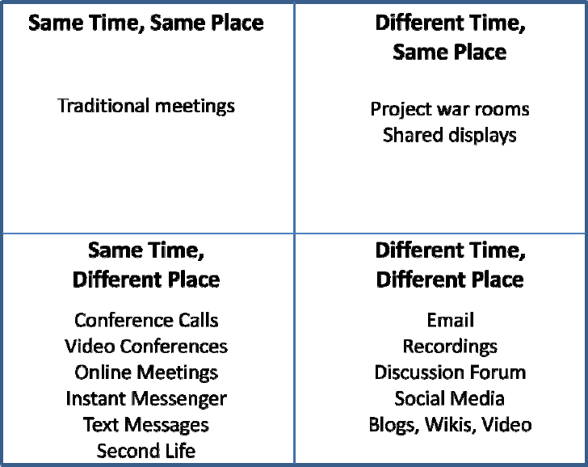
Exhibit 2: The time and place grid
The second secret is to make use of the fourth quadrant: different time, different place. These asynchronous tools are often forgotten, but it can make a real difference.

For example, instead of spending the whole of your virtual meeting showing presentations (which is likely to take a long time and risk losing engagement), share the presentation on a discussion forum and ask for comments before your meeting. Then you can use the virtual meeting to focus in on questions that people have raised and areas of interest.

Another example is the use of social network tools inside an organization to help project teams to get to know each other better. Harrin (2010) provided many more examples of the use of social media for project teams.

Secret #3 Preparation Is Crucial
Virtual meetings need preparation. This does not just mean setting up the technology, but making the following clear before and at the start of the meeting:
- What the purpose of the meeting is;
- The objectives which need to be achieved by the end of the meeting;
- A timed agenda;
- Clear roles, including facilitator (or chair), timekeeper and scribe (to take down action points and record decisions made);
- Agreed ways of working (or ground rules) such as “State your name before contributing” and “Mute when not speaking if you are in a noisy environment”; and
- Agree how actions will be recorded, communicated, and followed up.

Our clients have found the graphic in Exhibit 3 to be a good visual reminder of each of these points:
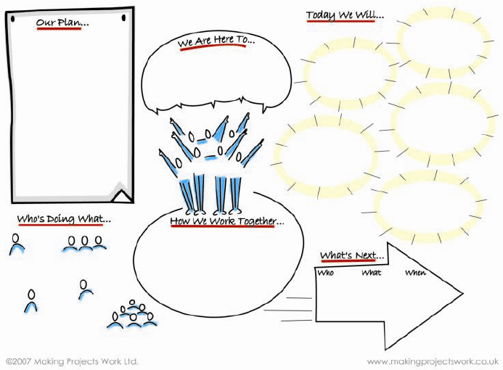
Exhibit 3: The Making Projects Work Ltd. start up template for meetings.

Secret #4 Give Up on Control
In face-to-face meetings, command and control sometimes still works. The leader can say, “You do this. You do that.” It just does not work virtually, although I know there are people who try. You cannot control people when they are in a different location and when you cannot see what they are doing. Some people will disconnect. Others will pretend to be present, but work on their e-mail instead. What is needed in virtual meetings is collaboration, to engage people and work together. This means that the leader must take on the role of facilitator, drawing out what's needed from the rest of the group and literally ‘making it easy’ (the root of facilitator) for the group to succeed.

Secret #5 Create a Level Playing Field
I often hear horror stories of how individuals are asked to join workshops by dialing in all day from a remote location. In one such story, the individual was in the United Kingdom and the group was in the United States. The individual dialed in at 2 p.m. and staying on the line until 10 p.m. at night. After a short introduction, the face-to-face team appeared to forget about him and, looking back, he felt that the entire eight hours spent on the phone had been a complete waste of his time.

The secret to solve this is to design for a level playing field. If one person needs to dial in, then why not have everyone dial in? An alternative is to hold a face-to-face meeting and reserve a portion of that meeting for talking with and focusing on the individual who can dial in just for that part.
Part of this secret is to be aware of people's cultures and treat everyone with respect, not just those who happen to share your culture. A level playing field isn’t just about access to technology!

Secret #6 Keep People Engaged By…
The biggest challenge for companies that I work with is to keep people engaged and interested in virtual meetings. The most powerful things that I have found to keep people engaged are:
- the use of story,
- visuals representing the work and picture maps of everyone, and
- keeping people involved.

Our brains are hard-wired for story from thousands of years of oral tradition. I took part in an international research project that established that information in story form was more effective in building relationships than simple lists when working in virtual teams (Thorpe, 2006).

As humans, we have multiple senses and on conference calls, we are only using our hearing. By adding visuals, whether on a shared screen or on preprinted sheets, we are adding another sense. When people are concentrating on a visual related to the work, they are less likely to be distracted by e-mail or things going on around them.

Many of my clients explain that it is very difficult to engage with disembodied voices. One way to counter this is to provide a picture map, with a photo of each person on the conference call or online meeting superimposed on a map.

My final suggestion for engaging people is to give them things to do. Roles such as timekeeper and scribe can be rotated around the team. Different people can facilitate different parts of the virtual meeting. Ask people for their input. Make sure that everyone has a chance to provide his or her point of view.

Secret #7 Check for Intentionality
It appears to be much more difficult to get people to take action after remote meetings compared to face-to-face meetings. This is my own experience and that of my clients as well. Project team members take action because of the commitment they have to the project. It is more difficult to build trust virtually and lack of action destroys what little trust has been built up. This can become a vicious circle.

To make actions more likely to be carried out, agree how actions will be documented and followed up, right at the start of your virtual meeting. Run through the actions at the end and check that everyone is clear on what they need to do and when. It is worth checking people's intentionality: On a scale of 1 to 10, how sure are they that they will carry out each action? If this number is lower than 10, it might be better to change the action slightly to make it more likely that it is carried out. After all, imperfect action that is taken trumps perfect action that never happens.

Conclusion
Virtual meetings are a fundamental way of getting things done for many project managers today. Many virtual meetings are frustrating and ineffective. With a little thought and preparation, they can be made both effective and efficient.

Climate Change Group. (2008). SMART 2020: Enabling the low carbon economy in the information age. Global eSustainability Initiative (GeSI). Retrieved from http://www.smart2020.org/publications/

Hall, K. (2007). Speed lead: Faster, simpler ways to manage people, projects and teams in complex companies London, England, and Boston, MA: Nicholas Brealey.

Harrin, E. (2010). Social media for project managers. Newtown Square, PA: Project Management Institute.

Kane, G. (2010). Virtual working. Proceedings of the Virtual Working Summit 2010. Loughborough, UK: Making Projects Work Press.

Pullan, P. (2008). Mindmap of conference call frustrations. Survey available from http://www.conferencecallsmadeeasy.com

Pullan, P., & Settle Murphy, N. (2005). The twelve crucial questions 2005. Retrieved from http://www.conferencecallsmadeeasy.com
Thorpe, S., Brown, H., Harkess, C., Lauder, G., Hollingworth, M., Spain, M.,…Martony, E. (2006, October). Narrative in online relationship building. Retrieved from http://www.onlinestory.net/index.php

